Joseph Kelley
ISOM 835
12/11/25
Telco Analysis and Machine Learning Development Project
The purpose of this project is to develop machine learning models and statistical analysis of Telco data related to customer churn, and to present valuable findings and business insights.
- Objective and key features
- Data preprocessing and cleaning
- Segmentation Rationale
- Statistical results
- Model development
- Model results
- Business insights and recommendations
- Supplementary visualizations
- AI-Usage Statement, References, and Acknowledgment of Tools Used

- Objective
The objective is to develop the most accurate model for predicting customer churn according to many different features incorporated into the raw data. A documentation of key features has been developed in tandem with this development.
#0 = FALSE, 1 = TRUE for numeric answers
#customerID: Customer ID. (Not important)
#gender: Whether the customer is a male or a female. (Male, Female)
#SeniorCitizen: Whether the customer is a senior citizen or not
#Partner: Whether the customer has a partner or not
#Dependents: Whether the customer has dependents or not
#tenure: Number of months the customer has stayed with the company
#PhoneService: Whether the customer has a phone service or not
#MultipleLines: Whether the customer has multiple lines
#InternetService: Customer's internet service infrastructure (DSL, Fiber Optic) (No = Customer has no internet service)
#OnlineSecurity: Whether the customer has online security or not
#OnlineBackup: Whether the customer has online backup or not
#DeviceProtection: Whether the customer has device protection or not
#Whether the customer has tech support or not
#StreamingTV: Whether the customer has streaming TV or not
#StreamingMovies: Whether the customer has streaming movies or not
#Contract: The contract term of the customer (Month-to-month, One year, Two year)
#PaperlessBilling: Whether the customer has paperless billing or not
#PaymentMethod: The customer's payment method (Electronic check, Mailed check, Bank transfer, Credit card) (Bank transfer and Credit card are automatic payments)
#MonthlyCharges: The amount charged to the customer monthly.
#TotalCharges: Total amount billed to the customer.
#Churn: Variable the model should attempt to predict: Whether the customer churned or not.
Many variables have been cleaned for usage in the final model used for machine-learning behavior, as the raw data consisted of many columns with multiple results. The methods of data cleaning are examined further on the following page.
- Data preprocessing and cleaning
For usage in the statistical models, the data was cleaned by converting stray alphanumeric number characters or human booleans into binary. (I.E. “Yes” becomes “1” and “No” becomes 0)
Any derivative results that could be mapped logically as 1:1 (I.E. it is impossible for a customer with no phone service to have multiple phone service lines) were mapped to 0 and 1 accordingly.
Additionally, irrelevant features such as customerID were scrubbed from the dataset, to prevent accidental fitting of randomly assigned identification numbers.
One-hot encoding was used to replace any columns that incorporated multiple answers such as “PaymentMethod”, creating individual data columns represented as 0 and 1 for each result.
However, PaymentMethod was important enough to justify segmenting further into whether payments were automatic or not. Intuition states that customers not opting into the ease-of-access and prevention of delinquency that automatic payments provide could cause them to churn.

The most important preprocessing step was to remove the InternetService option, for reasons which will be understood in the following pages.

- Segmentation Rationale
Briefly examining a finished machine learning model of the data delivers some insights that a data scientist may present to Telco.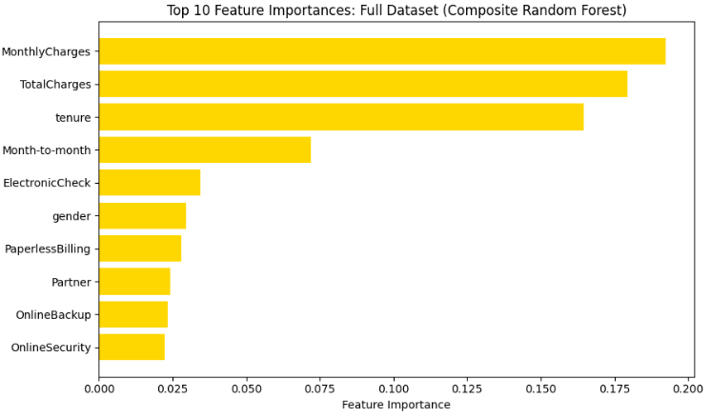
It appears as though MonthlyCharges is the most important factor in deciding customer churn. The naïve approach would be to suggest to management that customers are frustrated with monthly billing. However, basic statistical analysis proved that whichever value was present in “InternetService” caused significant differences in customer churn behavior.
As such, I have developed three statistical models and machine learning algorithms for this dataset: one for each of the three options.
No Internet: Customer does not have internet access via Telco.
DSL: Customer uses Digital Subscriber Line technology, affordable but limited.
FiberOptic: Customer uses Fiber Optic technology: expensive but high quality.
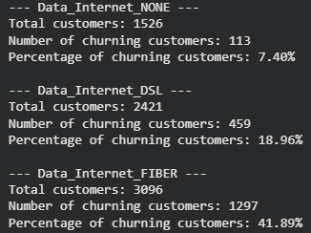
- Statistical results

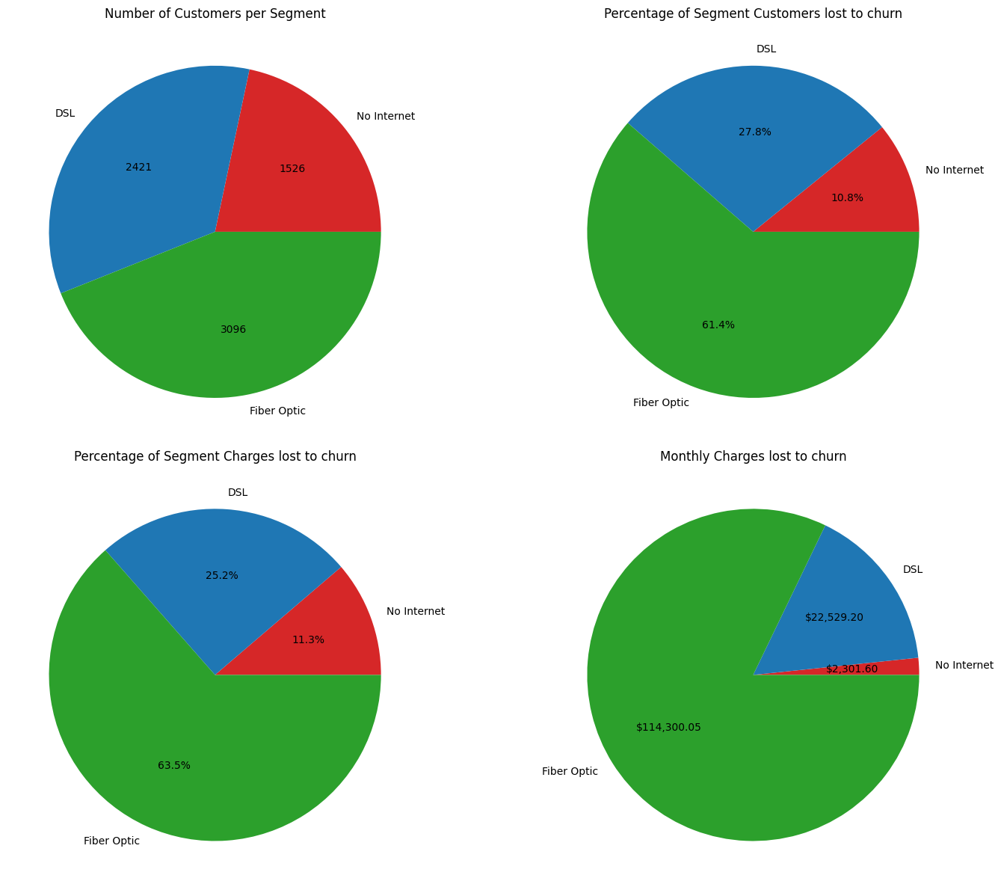
Already, with this one block of data, we can see that the problem is complex enough to justify development of three models.

- Model Development
As stated previously, three machine learning algorithms were trained on each segment of this data in hopes of developing the most accurate model. All models were trained using a test/train split of 80:20. More detailed hyperparameters are listed below.

Random Forest:
n_estimators 100, max_detph 20, n_jobs 1, random_state 42

Gradient Boosting:
n_estimators 100, learning_rate 0.1, max_depth 5, random_state 42

Support Vector Machines:
Kernel=”rbf”, C=1.0, gamma=”scale”, random_state 42

Ten models were developed in each category, for a total of 90. The most accurate model was stored for No Internet, DSL, and FiberOptic. Models were evaluated using Accuracy, Precision, Recall, and F1-Score.

The best model for No Internet was Gradient Boosting.
The best model for DSL was Gradient Boosting.
The best model for FiberOptic was Random Forest.

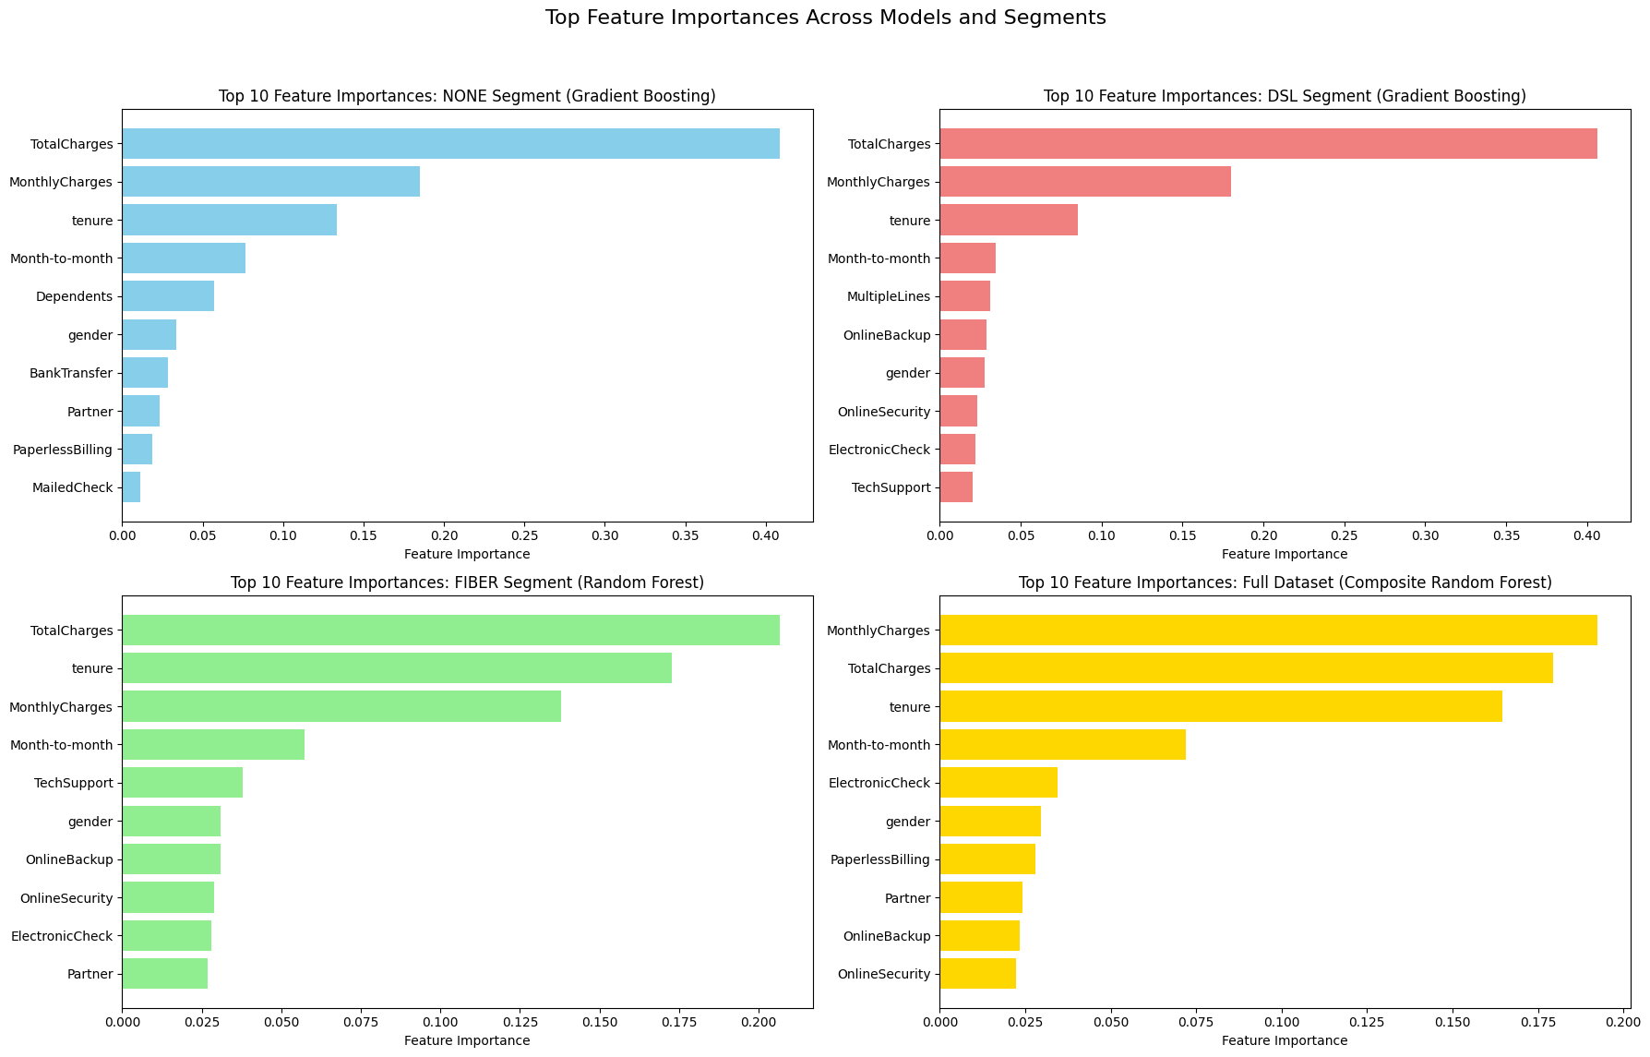
- Model Results
Upon further analysis, it has become clear that TotalCharges is the most important factor in developing churn, not MonthlyCharges!
The initial results (in yellow) make intuitive sense. Significantly more customers churned on FiberOptic, which has the most customers, and the highest monthly charge. But diving deeper has revealed the truth.
More interesting is that each segment seems to have a different set of important factors. The results will be expanded in detail on the following page.

- Business insights and recommendations
The most important feature being “TotalCharges” suggests that customers have been experiencing frustration with extended tenures with Telco. Perhaps Telco could install perks for long-standing customers to mitigate this.
MonthlyCharges was still important, but the issue seems to be in problems with retention more than problems with value proposition. Tenure being the third or second highest factor backs this up.
Customers having month-to-month contracts also causes increased churn. This makes intuitive sense, as year or 2-year contracts typically have decreased rates in exchange for longer terms.
For gender, 1 = Male. In all models, male customers were identified as a source of churn.
For customers lacking internet, a lack of dependents was identified as a somewhat important factor. This suggests that customers with dependents (such as children) want internet access. If the customer has no children, offering a no-internet plan may be viable.
For customers utilizing DSL, multiple phone lines arose as a source of churn. This suggests frustration with slower internet being bundled with multiple lines, which may be an excess.
For customers utilizing FiberOptic, advanced features such as TechSupport, OnlineBackup, and OnlineSecurity rose to moderate prominence in predicting churn. This suggests customers see Telco’s tech services as inadequate or lacking value.
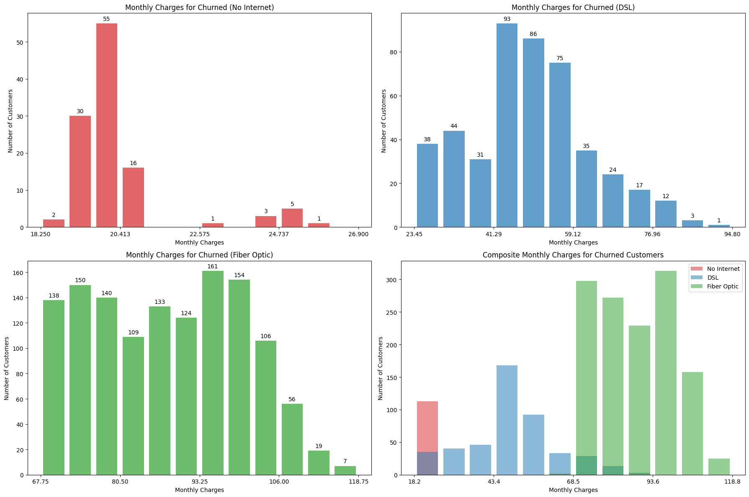
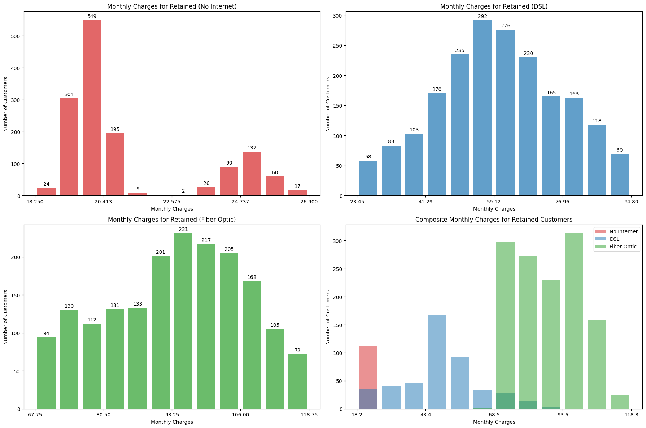
- Supplementary Visualizations
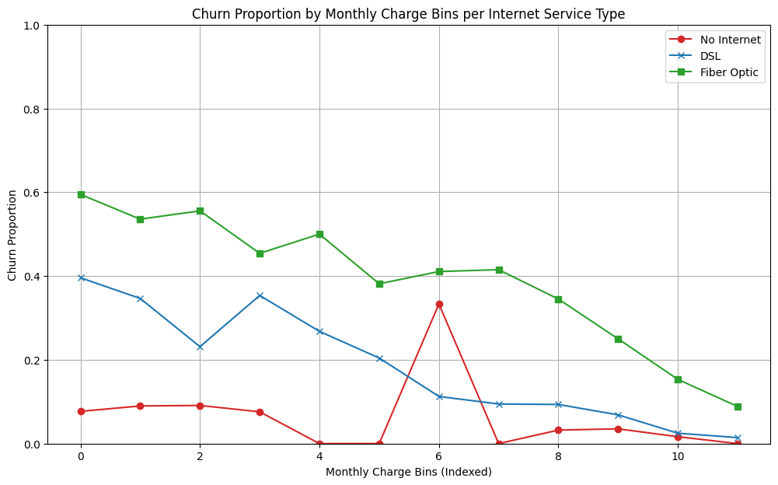
These visualizations report on the “bins” of charges for customers. It seems that customers that pay more churn less. However, when these customers churn, it results in a higher loss of income. Note that the spike on bin 6 for No Internet is the result of an outlier in which 1 of 3 customers in that bin churned.

AI-Usage Statement, References, and Acknowledgment of Tools Used
Google Gemini was used extensively to handle the technical implementation of features in this project.
Libraries used:
Pandas
Numpy
SkLearn
MatPlotLib
Seaborn
TensorFlow
Machine Learning tools “train_test_split”, “RandomForestClassifier”, GradientBoostingClassifier”, “SVC”, “accuracy_score”, “precision_score”, “recall_score”, “f1_score” were used from various SkLearn subdirectories.
Data can be found at:
https://www.kaggle.com/datasets/blastchar/telco-customer-churn
Due to the randomness of machine learning algorithms, some information regarding model outputs have been baked into data visualizations. Running this program does not guarantee identical results. However, highly optimized models were chosen.

